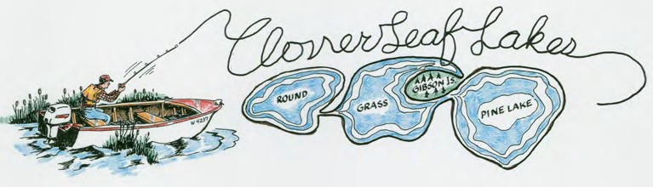
CLOVERLEAF LAKES PROTECTIVE ASSOCIATION
P.O. Box 288
Embarrass, WI 54933-0288

“Preserving Our Lakes for Future Generations”

Wisconsin’s Recreation Center
The Place for Health, Rest & Pleasure CLPA incorporated in 1936

Name:__________________________________________________________

Board of Directors
Christopher Sampson, President
csampson@new.rr.com

Kevin Goodman, Vice President
cloverleafprokg@gmail.com
Jessica Meier, Treasurer
jessicameier@uwalumni.com
Gary Schumacher, Secretary
gary@garyschumacher.com
Andy Hines, Director
ahines92@comcast.net
Peggy McMahon, Director
pmcmahon23@gmail.com
Jeff Casperson, Director
jcasperson@new.rr.com

Lake Address (if update is needed):_______________________________

Telephone (if update is needed):__________________________________

E-Mail (if update is needed):______________________________________

Home Address (if update is needed): _____________________________

Dues $ 25.00
Tax-deductible donation ____________
TOTAL ENCLOSED
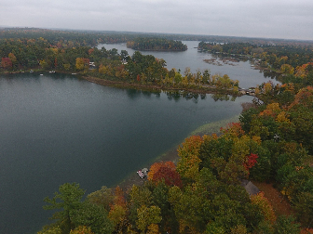
Thank you very much for your kind support of our lakes!

